Maritime Intelligence Section
Date: 07/08/14
Source: Allmode
Advisory Notice: 022
Launch of Joint Concentrated Inspection Campaign on STCW Hours of Rest

Please be advised that as of the 1st September 2014, The Maritime Authorities of the Paris and the Tokyo Memoranda of Understanding on Port State Control will launch a joint Concentrated Inspection Campaign (CIC) with the purpose to establish that watch-keeping personnel are meeting the requirements regarding hours of rest as per STCW 78 as amended (including the Manila amendments).

This campaign will last until the 30th November 2014.

The Port State Control Officers (PSCO’s) will need evidence to show the hours of rest for the deck and engine room watch-keepers, to establish that they comply with the recommendations set out in the STCW 78 amendment.

Port State Control Officers (PSCOs) will use a list of 10 selected items to establish that watch-keeping personnel are meeting the requirements regarding hours of rest, focusing attention on the Minimum Safe Manning Document (MSMD) and records of rest. In addition information will be gathered on the watch system, whether the MSMD requires an Engineer officer and whether the ship is designated UMS (Periodically Unattended Machinery Space). For this purpose, PSCOs will apply a questionnaire listing a number of items to be covered during the concentrated inspection campaign. The questionnaire has been annexed to this press release.
When deficiencies are found, actions by the port State may vary from recording a deficiency and instructing the master to rectify it within a certain period to detaining the ship until serious deficiencies have been rectified. In the case of detention, publication in the monthly detention lists of the Paris and Tokyo MoU web sites will take place.
It is expected that the Paris and Tokyo MoU’s will carry out approximately 10,000 inspections during the CIC.
The results of the campaign will be analysed and findings will be presented to the governing bodies of the MoU’s for submission to the IMO.

The information and opinions expressed in this report are the views of Allmode Intelligence section, part of Allmode Limited (“Allmode”) and constitute a judgment as at the Report time and are subject to change without notice. The information and opinions expressed in this Report have been formed in good faith on the basis of the information and intelligence available at the time of writing, but no representation or warranty, expressed or implied, is made as to its accuracy, completeness or correctness. Allmode accepts no liability arising out of or in connection with the comments made or the information set out in this report and the reader is advised that any decision taken to act or not to act in reliance on this report is taken solely at the readers own risk. In particular, any comments in this report should not be construed as advice, legal or otherwise.
The information contained in this report is taken from open source and from sites or messages received from Allmode Teams, UKMTO, MARLO, MSCHOA, IMB ICC and other sources. Allmode will publish with each report what source the information was gathered from
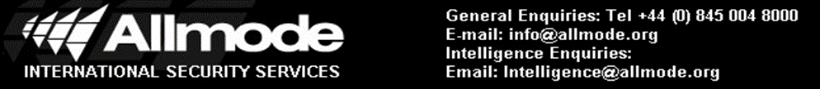

,
Incident Type: Suspicious Approach
Jfkjgjlgkdjgdfjgdglkdjggjgkdjgkgjgjdg

sglgfglkgdlkghdgkdiptoyiegohihbohb
ANTI – PIRACY UPDATE 104

