Maritime Intelligence Section
Date:
Source: Allmode
Advisory Notice: 035 (Libya)
WARNING, WARNING, WARNING

The Internationally recognised government of Libya and the Libyan Air Force (LNA), has sent out a warning to all ships coming into Libyan Territorial Waters and Libyan ports.

As of Friday 9th January, any ship approaching the port city of Misrata will be targeted directly and indirectly. The warning came from the Commander of the Air Force, Brigadier Saqr Al-Jaroushi.

This announcement comes after the Air Force announced on Monday, that it had acquired 4 new Russian-made Sukhoi SU-27 fighter jets reportedly capable of covering a distance of 3,530 km with a top speed of 2,500 kmh.

The LNA have apologized for the unprovoked strike on the Greek-operated Tanker that approached Derna port last Sunday.

Allmode Comment: Considering the on-going struggle for control of Libya’s valuable assets, the oil fields and terminals, it would not be advisable for any vessel to enter the main ports without the approval of the relevant authorities. However, this is an area of controversy, as some of the terminals are controlled by other factions, whether militants or the opposing government authorities. If a vessel must enter a Libyan port, a thorough risk assessment should be conducted before entering Libyan territorial waters.

The information and opinions expressed in this report are the views of Allmode Intelligence section, part of Allmode Limited (“Allmode”) and constitute a judgment as at the Report time and are subject to change without notice. The information and opinions expressed in this Report have been formed in good faith on the basis of the information and intelligence available at the time of writing, but no representation or warranty, expressed or implied, is made as to its accuracy, completeness or correctness. Allmode accepts no liability arising out of or in connection with the comments made or the information set out in this report and the reader is advised that any decision taken to act or not to act in reliance on this report is taken solely at the readers own risk. In particular, any comments in this report should not be construed as advice, legal or otherwise.
The information contained in this report is taken from open source and from sites or messages received from Allmode Teams, UKMTO, MARLO, MSCHOA, IMB ICC and other sources. Allmode will publish with each report what source the information was gathered from
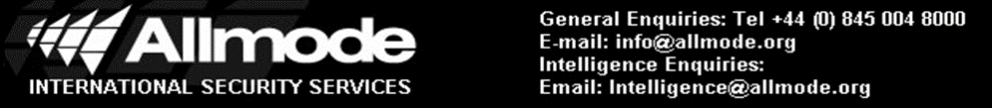

,
Incident Type: Suspicious Approach
Jfkjgjlgkdjgdfjgdglkdjggjgkdjgkgjgjdg

sglgfglkgdlkghdgkdiptoyiegohihbohb
ANTI – PIRACY UPDATE 104

