Intelligence Section
Date: 09/01/14
Source: Allmode
Advisory Notice: 034 ( India)
Vessels arriving in Indian Ports – Warning

Following the attempt from the terrorist group Lashkar-e-Toiba to carry out a terrorist attack on the port of Porbandara at the end of December, the Indian Authorities have told the Customs and Immigration Authorities to adhere to all documentation formalities for vessels entering Indian Territorial Waters, especially with regard to Security Guards, arms and ammunition on board vessels.

This is a reaction to the Pakistan boat that was blown up near to Porbandar and it transpires that the four men on-board the boat were active members of the terrorist group Lashkar-e-Toiba, who had planned to blow up the Naval base at Porbandar port, at a time close to when Prime Minister Narendra Modi is due to visit.

Sources say that the boat took the same route as the 26/11 terrorists Ajmal Kasab and others in Kuber in 2008. The four men on the boat were paid a huge amount by Lashkar handlers to execute the operation. Sources also added that the men on the boat were in regular contact with the Pakistan army and marine officials.

The boat came onto the radar a fortnight before the incident and all concerned authorities were alerted beforehand. According to these same sources, the entire operation was monitored by top Indian intelligence and security officials with the National Security Advisor's (NSA) assent.

As the Navy failed to take effective action, despite advance alert, an internal probe has been ordered over the incident. The diesel smuggling boat theory is considered to be incorrect, as smuggling boats do not come so close to the ports.

Please ensure that all your documentation is in order and that the correct procedures are carried out before entering Indian Territorial Waters.

The information and opinions expressed in this report are the views of Allmode Intelligence section, part of Allmode Limited (“Allmode”) and constitute a judgment as at the Report time and are subject to change without notice. The information and opinions expressed in this Report have been formed in good faith on the basis of the information and intelligence available at the time of writing, but no representation or warranty, expressed or implied, is made as to its accuracy, completeness or correctness. Allmode accepts no liability arising out of or in connection with the comments made or the information set out in this report and the reader is advised that any decision taken to act or not to act in reliance on this report is taken solely at the readers own risk. In particular, any comments in this report should not be construed as advice, legal or otherwise.
The information contained in this report is taken from open source and from sites or messages received from Allmode Teams, UKMTO, MARLO, MSCHOA, IMB ICC and other sources. Allmode will publish with each report what source the information was gathered from
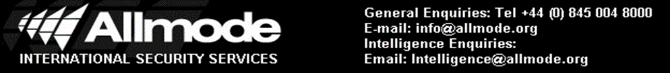

,
Incident Type: Suspicious Approach
Jfkjgjlgkdjgdfjgdglkdjggjgkdjgkgjgjdg

sglgfglkgdlkghdgkdiptoyiegohihbohb
ANTI – PIRACY UPDATE 104

